INSTRUCTIONS FOR INSTALLING YOUR EVERLOC SOLUTIONS BATHROOM SHELF-LARGE

Cleaning/Preparing the surface
Clean the mounting surface thoroughly. Ensure that the surface is completely dry and free of any dirt or residue. For best results use rubbing alcohol or similar to clean the surface prior to installation.

Installation
- Remove protective plastic cover from the suction cups (Fig.1).
- Determine placement of your suction cups by using the accessory as a guide. The rear spacer should be against the wall.
TIP: Please ensure the suction cups are not placed over any joints or grout lines as this could interfere with the adhesion.
The suction hooks should be installed in an upright position so that the product can latch onto the hooks.
Please ensure you adequately space the suction cups apart for even weight loading.
- Once satisfied with the positioning of the suction cups, apply each suction cup with a quick firm push using the base of your hand-you should feel the suction cup pop when it is adhered properly (Fig.2). Please take care when installing product on surfaces such as glass or mirror. Once installed correctly the suction cups should remain securely attached and should be difficult to remove by hand. When installing product with multiple suction cups, ensure the suction cups are parallel (Fig.3). If your product has not been aligned correctly, the product will hang crookedly causing uneven weight loading.
- Once all suction cups have been installed, hang the product on the hooks by carefully sliding the product downwards until you hear a slight click.
- Check the installation of the product prior to loading. Firmly tug on the accessory to check it has been installed properly. Make sure that the suction cups are securely attached and the accessory has been correctly assembled (Fig.4).
NB: Check your suction cups periodically for adhesion. Remove, clean & reapply if necessary.

67009 – SOLUTIONS BATHROOM SHELF - LRG
DEC 2012

Removing the EVERLOC product
- Prior to removing your EVERLOC product you will need to remove all loose accessories and objects that you have placed on top of or inside your EVERLOC.
- Once empty, begin by removing the accessory from the suction cups. Start on one side of the product and push the product in an upwards motion to release it from the hooks.
- To remove your suction cups it is recommended you use a flat piece of plastic or cardboard eg: a business card to carefully slide underneath the suction cup to break the seal (Fig.5). Please avoid the use of sharp objects that may cause damage to the surface or suction cups eg: knifes, pens, pencils.
- To prepare suction cups for reinstallation it is recommended that you soak the suction cups in hot water for 15 minutes to allow it to reset, then leave to air dry.
NB: Avoid hand drying with towels as lint can stick to the suction cup and interfere with adhesion.
Once completely dry, the product will then be ready for use in a new location.

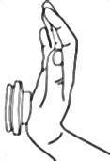
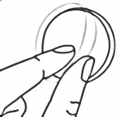
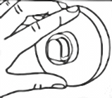

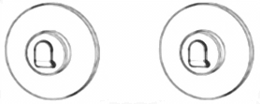
>

>

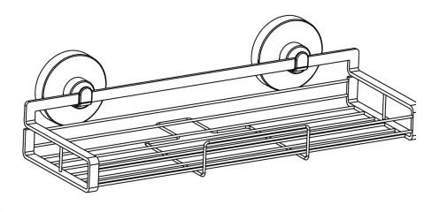

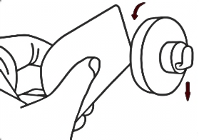

www.everloc.com.au
info@everloc.com.au

Caring for your EVERLOC
To clean your EVERLOC accessory, use a damp cloth to wipe down all surface areas. Rinse under warm running water if required and leave to air dry. Do not use any harsh cleaning solutions, bleaches or abrasive cleaners as this may damage the chrome coating.
When cleaning suction cups only use warm running water as harsh abrasives can damage the suction and interfere with adhesion.
Leave suction cups to air dry after cleaning or resetting and avoid hand drying with towels as lint can stick to the suction cup and may interfere with adhesion.

Precautions
- The weight rating as indicated on the packaging is a maximum rating of the suction cups under ideal conditions & should be used as a guide only.
- The maximum weight bearing ability of EVERLOC will vary from surface to surface.
- The installation surface must be thoroughly cleaned and dried before installation, ensuring any residue from cleaning products is removed. For best results use rubbing alcohol to clean surface prior to installation.
- Read cleaning instructions carefully. Please refer to ‘Caring for your EVERLOC’.
- This product is designed for use as per the illustration on the packaging and if used accordingly, should provide consistent performance.
- EVERLOC and the retailer are not responsible for any damage or injury resulting from use or misuse of the product.
- Do not overload the product.
- Do not use the product as a grab bar or security rail.

